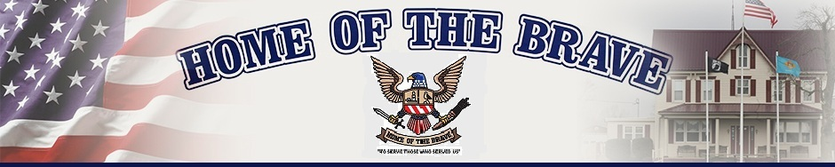
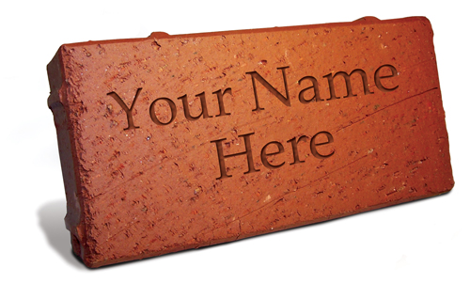
HOB II (female transitional facility)
CAPITAL CAMPAIGN
C/O Home of the Brave
6632 Sharps Rd
Milford, DE 19963

Donation: $100.00 per brick (100% Tax Deductible) BRICK SIZE 4X8
Make Checks payable to: Home of the Brave
Please print form, fill out completely and mail form along with a check to the above address.

You may provide up to three lines of inscription. The top line may say “In honor of” or “In memory of” if you choose. Military Branch, Ranks, etc. are permitted.

Each paver may contain up to three (3) lines with 18 characters per line (lines will be centered).
Spaces & Punctuation such as dashes or commas are counted as a character. Home of the Brave reserves the right in its sole discretion to deny any application and return the paver donation. Questions can be directed to Jessica Finan at jfinan@homeofthebravefdn.org or 302-424-1681.

I would like my inscription to read: (18 characters per line only)

___/___/___/___/___/___/___/___/___/___/___/___/___/___/___/___/___/___/

___/___/___/___/___/___/___/___/___/___/___/___/___/___/___/___/___/___/

___/___/___/___/___/___/___/___/___/___/___/___/___/___/___/___/___/___/

Name _______________________________________________

Address ______________________________________________

City, State, ZIP _________________________________________

Daytime Phone ________________________________________

EMAIL _______________________________________________

